**OS-Project Phase 1**

Anas Madkoor 202104114

Faisal Elbadri 202107288

Rashid Nafwa 201912873

|  |  |  |
| --- | --- | --- |
| Name | Tasks | Percentage |
| Anas Madkoor | Server-Side Tasks (VM1): Task 1, Task 2, Task 3 | 33.3% |
| Faisal Elbadri | Client-side Tasks (VM2) and (VM3): Task 1 and task 2 | 33.3% |
| Rashid Nafwa | Client-side Tasks (VM2) and (VM3): Task 2 and task 3 | 33.3% |

GitHub repository: <https://github.com/C974/Operating-System-Project>

Task 1:

1.1: Create User (Client 1) = server

Password of client 1 (SFTP): **Os-project!12345**

Verify the creation of client 1



1.2: Install and Enable SSHD

Inside the server we created client 2 client 3 with **Os-project!12345, password**

Configured static ip address for client 2 and client 3,

┌──(client1㉿kali)-[~]

└─$ sudo nano /etc/network/interfaces

Verifying the ip addresses using ip a command on the server which we’ll need in task 3

**Modify SSH Configuration for SFTP Access**

--------------------------------------------------------------------------------------------------------------

Task 2:

2.1 SSH and SFTP Configuration:

sudo nano /etc/ssh/sshd_config



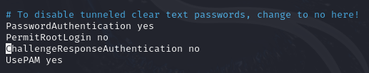

Created file with “touch test.txt” on my Desktop then we sftped to the server and uploaded the file, we used ls command on the server to verify that the file was uploaded successfully.

Now after we have the file uploaded, we downloaded it from the server to desktop while renaming it to test2.txt

**Task3:**

Pinging client 2 192.168.15.130 and client 3 192.168.131 that we configured the static ips in task 1

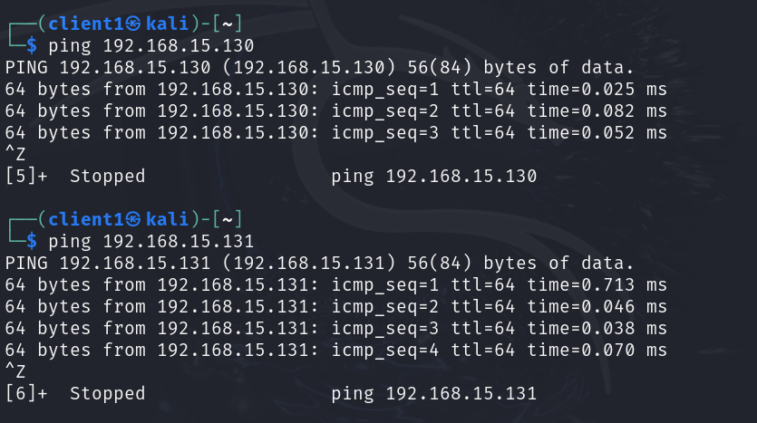

Created network.sh

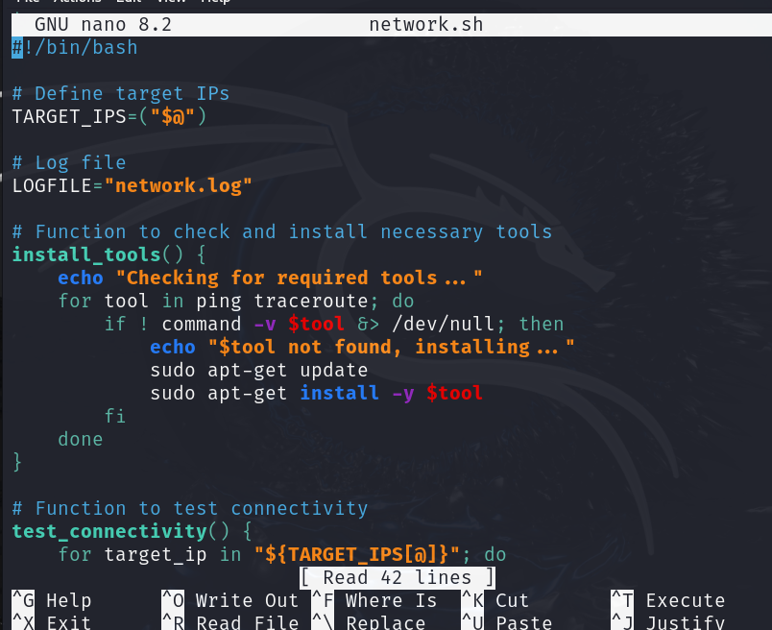

Created tracroute.sh

Changed privileges to be able to write the network.log file

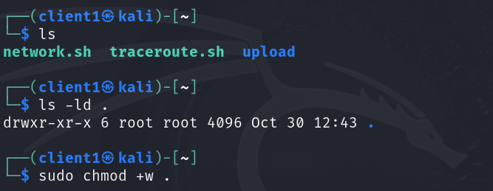

Ran the network.sh file using this command sudo ./network.sh "192.168.15.130 192.168.15.131"

**Test run 1**

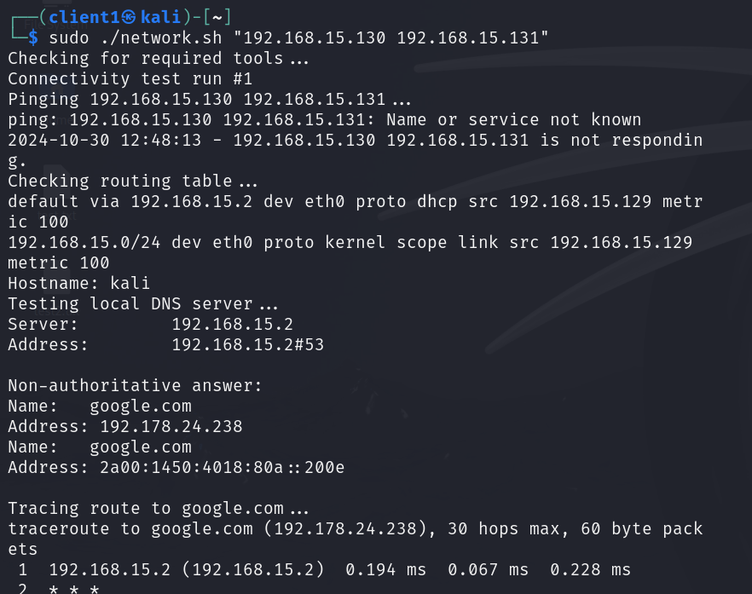

Test run 2

Test run 3

Now we have network.log file which stores the output in the log file

**System.sh:**

System.sh, disk_info.log and mem_cpu_info.log files

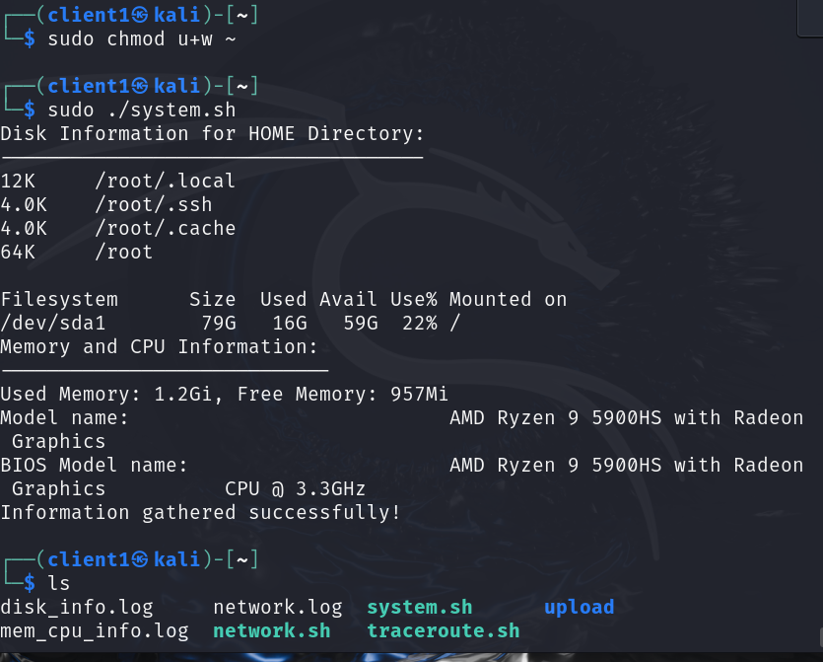

Zipped the files

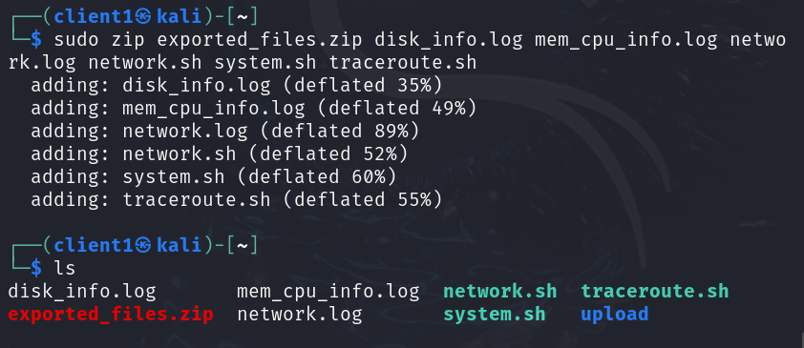

Downloaded them in our host machine (kali) in the download folder

**Client Machine Setup (VM2 and VM3):**

**Task 1:**

Install sftp client

Checking if scp is installed

Task 2 configuration:

Shh to client 2

Shh from client 2 to client 3

Sftp to client 2

Sftp to client 3

**Task 3 Shell Scripting:**

Login.sh in client 2

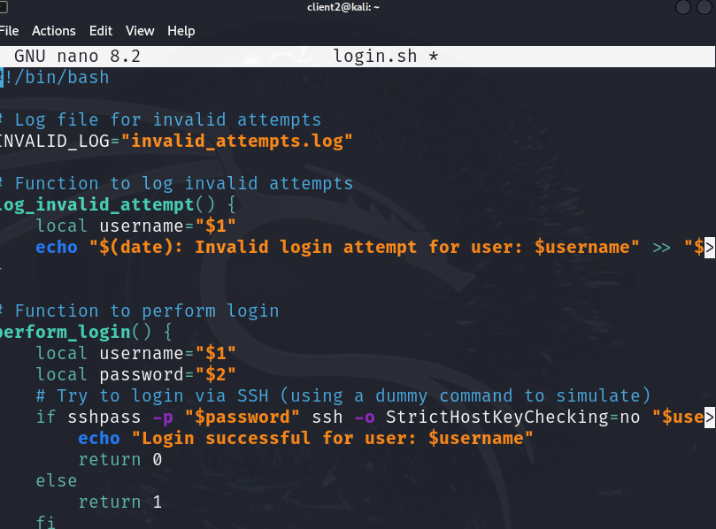

Check.sh

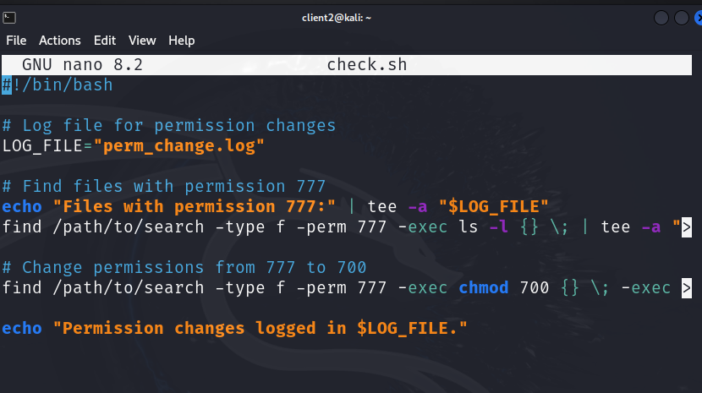

Then we zipped both login.sh and check.sh

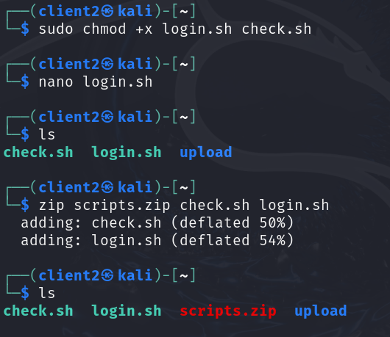

Downloaded the zip file we just created on our host machine (kali)

**Client 3 Side Shell script 1: (Search.sh):**

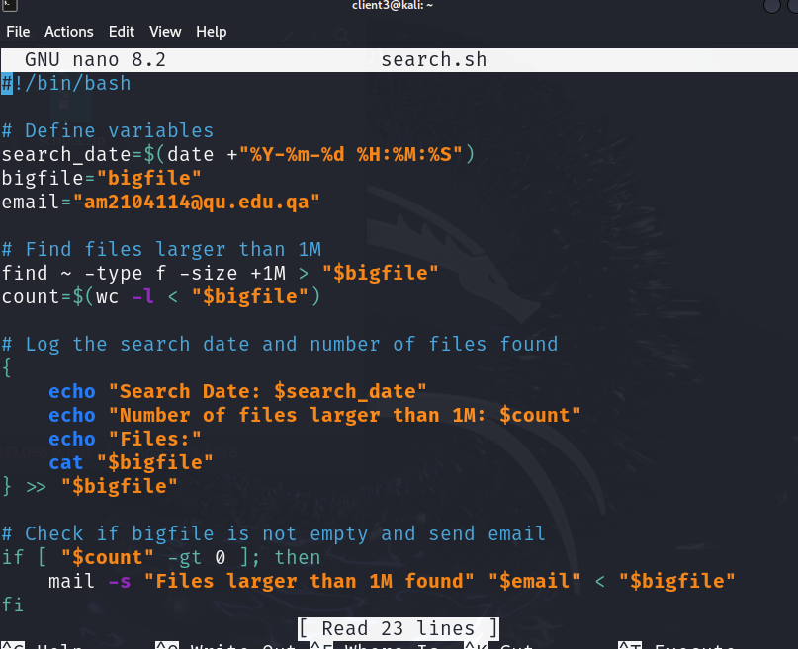

Clientinfo.sh

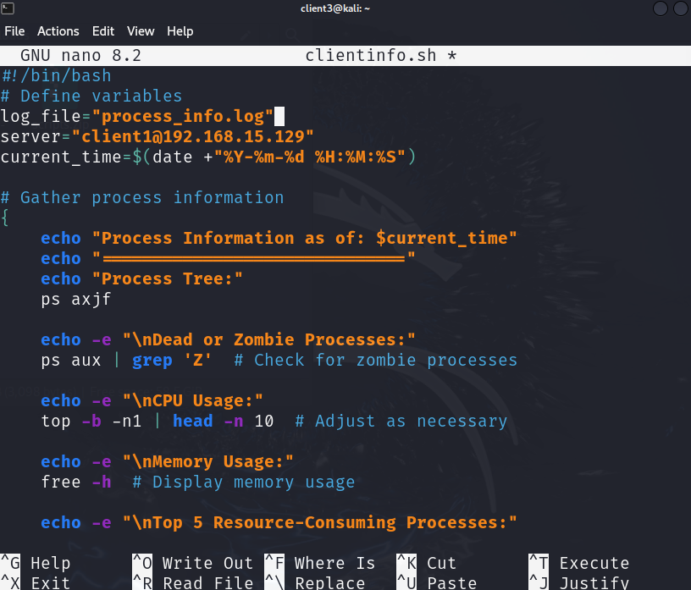

To run the script every hour

0 * * * * /home/client3/clientinfo.sh

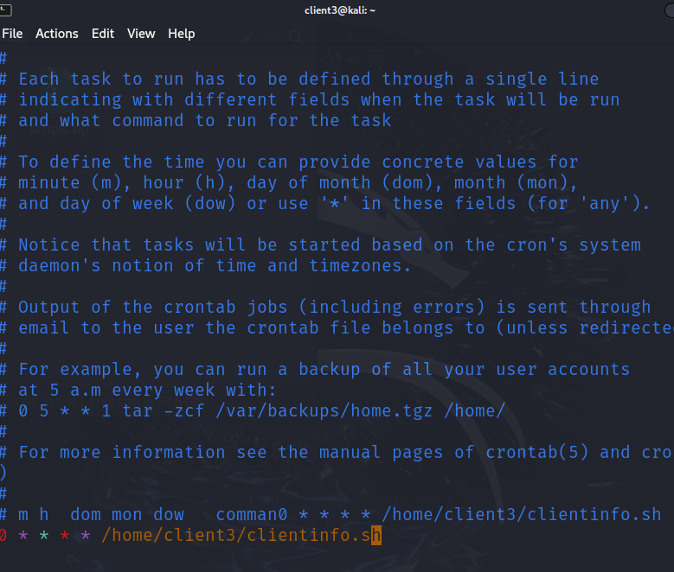

Now we zip the files

Now we download the file from kali the host machine

